Abstract Template and Guidelines

Dear Contributor of ICEP 2019,

In an effort to improve the conference quality, we would like to ask you to prepare an abstract using the attached template to help us better evaluate your submission. The abstract should contain about 1 page of text and 1 page for supporting figures and tables, with a total length of 2 pages at maximum.
The title, author, affiliation, keyword information entered in the online submission process will be used.
It is unnecessary to describe them in the abstract file.
Figures and tables to support the point of the paper will receive positive considerations.
Technical experts assigned by the conference technical program committee will review your abstract, and their comments will be used in the selection process. The degree of novelty in your technical approach is a major component of the evaluation criteria used in the selection process. You are strongly discouraged from submitting work that has already been presented at a conference or has already been published elsewhere.
Your abstract will be used for review purpose only and will not be included in the conference proceeding.

Thank you very much for your contribution!

ICEP2019 Organizing Committee

TEXT
Please write your abstract text here.

Abstract should contain about 1 page of text and 1 page for supporting figures and tables, with a total length of 2 pages at maximum.

The title, author, affiliation, keyword information entered in the online submission process will be used.
DO NOT include the abstract title and author name(s) in your abstract text.

Briefly describe the background of your work and the problem to be solved.
Your description should help the reviewers to evaluate the significance of the problem. References should appear on the bottom of the first page¹.
Clearly describe your technical approach, scientific basis, and tasks you undertook to solve the problem.

All abstracts must present original research and at least preliminary results.
Do not submit an abstract for planned work.
You may place all your figures and tables on the second page.

J. K. Author, “Title of paper,” in Unabbreviated Name of Conf., year, pp. xxx-xxx.

Figures
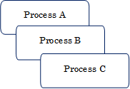
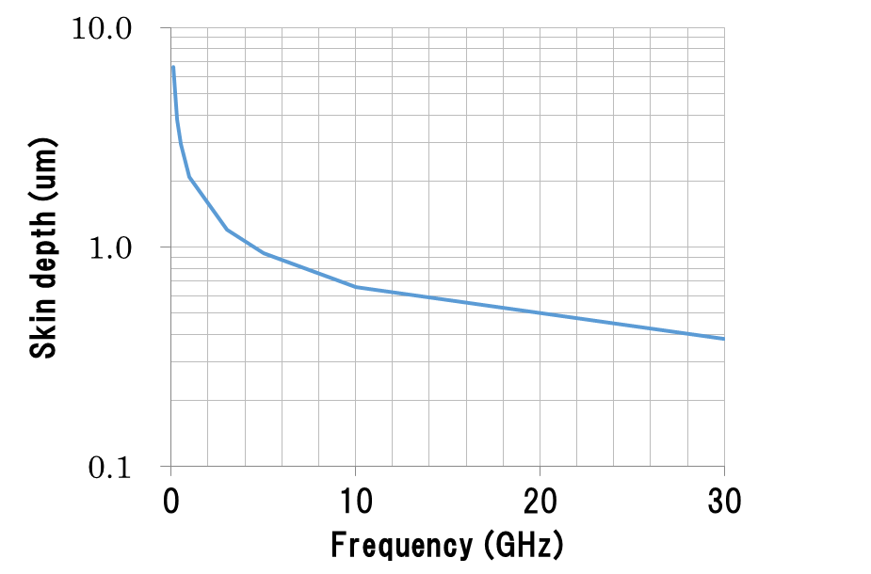
Fig. 3: You may include up to six figures on the second page.
Fig. 2: When using photos, make sure the resolution is sufficient.
Fig. 1: Briefly describe figure contents, preferably self-explanatory.
Be sure to use sufficiently thick linewidths in your drawings.

